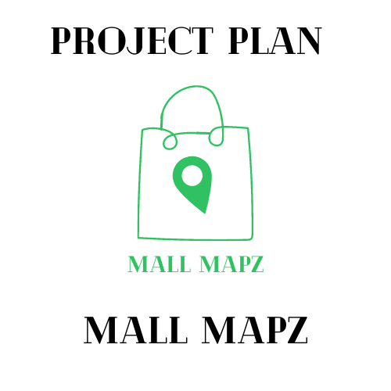

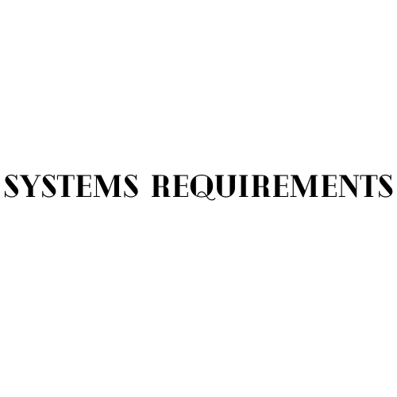



The Cartographers

Lara Leyson, Daniel Pearson, and Romer Rodriguez

April 6, 2022

**Introduction (RR):** The purpose of the following document is to summarize the system requirements of the the app “Mall Mapz”. This document includes an in *depth description model*, *class diagram*, *use case diagram*, *use case scenarios*, and a *system sequence chart*. The *description model* is a short summary of each requirement in the system. The *class diagram* contains a visual diagram of the systems objects, methods, and attributes along with their associations to each other. The *use case diagram* goes over each use case in the system. The *use case scenarios* go over the possible events and exceptions that can occur. At last the *system sequence charts* will show a sequence diagram for each use case scenario.

**Description Model:**

**Initial Requirements( RR):** Since “Mall Mapz” is a mobile application, it will be based on working with android and apple based mobile operating systems. Users of “Mall Mapz” will need some form of internet connection, as well needs to have their mobile device have GPS enabled in order to use the GPS and Interactive map functions. -Romer

**Security (RR):** Users using “Mall Mapz” are protected by 2-step verification through their choice of either phone number or email to verify themselves. Users have a unique username along with an encrypted password in order to access their profiles. Users' locations are protected through google maps integrated security functions.

**Processes:**

**GPS (RR):** The GPS function is based on google maps which is integrated into the app. It works by the user entering the mall they would like to head to. From there the user is given directions on how to get there and their gps is tracked along the way to help the user get to their location.

**Store Information (RR):** Store Information function works by first the user searching for the store or selecting it from the interactive map. Once selected the user is displayed all information available on the store that the app contains that information includes tags, description, hours, etc.

**Search (RR):** The search function in Mall Mapz works as a search for stores and malls. Using this function, the search will show you all sorts of stores or malls you type in the searchbar of the app. Can be any numerical number, sign, letter, address anything you type into the search bar; locations for the desired store/mall will come up for you.

**Reviews (DP):** The reviews function in Mall Mapz is a way for people from all parts of the United States to leave reviews for certain stores, malls or restaurants. The rating of the store/restaurant is counted through a star score of 1-5 stars, the individual can leave a comment with the rating that they give to give a review on why they gave that store that rating. With this function, it makes it easier for the people looking for the store and why or why not they should shop there.

**Interactive Map (DP):** The Interactive Map function works as a GPS inside the mall, showing how to get certain stores inside or outside the mall. The map will show you how close or far you are from the destination, it’ll show a dotted line like a bread trail on how to get to that store. This function makes it easier for people who get lost in a mall very easily and the itinerary inside the mall is’t present for them.

**Profile (DD):** The profile function is where you can show who you are by having a profile picture, name, interests/favorites, any reviews you left and or places you visited. This function will help you connect with Mall Mapz more because in the profile you’ll be able to choose your interests on what you specifically look for when going shopping.

**Class Diagram (LL):** Please look at the Mall Mapz GitHub Repository

**Use Case Diagram (RR):** Please look at the Mall Mapz GitHub Repository

**Use Case Scenarios (DP):** Please look at the Mall Mapz GitHub Repository

**System Sequence Charts (LL):**  Please look at the Mall Mapz GitHub Repository